**Date:** 5th September 2016

**Location:** Library Project Room 3.1

**Attendees:** Weilun, Zong Wei, Wendy, Ching Yi, Gao Min

**Absentees:** -

**Minutes Prepared by:** Wendy

**Vetted by:** Ching Yi

**Points to Note**

1. Vet through Expert Testing II’s survey feedback form:

<https://docs.google.com/forms/d/e/1FAIpQLSfVzckqskA4Z1OeOs3DEX7BP1LPR6HR0_xKQNUleTDMh_zsew/viewform?fbzx=8417448485646342000>

1. Edit minor changes of the app for Expert Testing
2. Discuss on the Analytics tab:

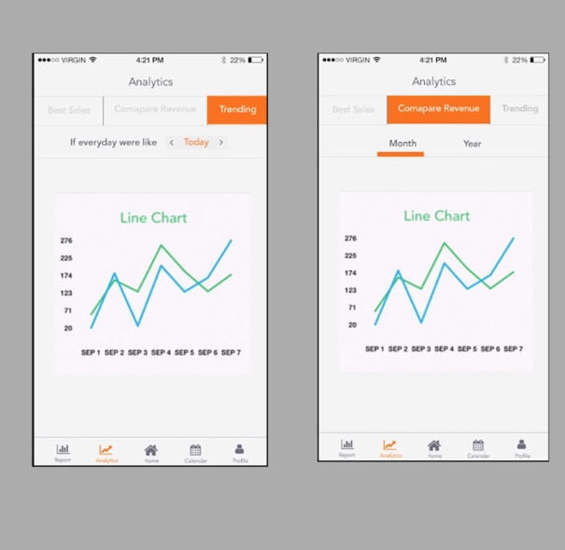

* Tab field confirm
* Best sales 🡪 First layer: Month, Year || Second Layer: After choosing month, choose the year
* Compare Revenue 🡪 First layer: Year || Second Layer: Upon clicking year, month come out
* Trending 🡪 Date, Week, Month and Year

1. **Front-End**

**After Expert UI change (by Friday, 9th September 2016):**

***image view tap*** - by Tuesday, 6th September 2016

***segmented control – for analytics view*** - by Tuesday, 6th September 2016

border for sales and expenses button

set monthly target - graph

main page overview

calendar icon (list, add)

calendar single view

icon and font standardize

tab bar icon

1. **Back-End**

**After Expert Backend (by Friday, 9th September 2016):**

Analytics Function

Image View Capturing

Malay translation

Sending of SMS registration (after iteration 7)

1. **Quality Assurance**

Start on strict app testing and update bug metrics

1. Pending Discussion: Multiple receipt

**Note:**

Check with Edmund: removal of sub-user, reason being: hawkers with multiple stall would mostly be using iPOS system

Meeting is adjourned at **1600**.